

DR. D. Y. PATIL VIDYAPEETH, PUNE
(Deemed to be University)

DR. D. Y. PATIL SCHOOL OF SCIENCE & TECHNOLOGY, TATHAWADE, PUNE.

A Mini-Project Report on
Customer Segmentation in Mall
SUBMITTED BY

Ms.Tanaya Shinde BSc - 2349
Ms.Saniya Mulla BSc - 2322
Ms.Shravani Patki BSc - 2332

GUIDED BY:
Ms. Gayatri Bhise

BACHELOR OF COMPUTER SCIENCE
ACADEMIC YEAR 2024-25

DPU-SST, Department of Bachelor of Computer Science 2025-26

DR. D. Y. PATIL VIDYAPEETH, PUNE
(Deemed to be University)

DR. D. Y. PATIL SCHOOL OF SCIENCE & TECHNOLOGY, TATHAWADE, PUNE.

CERTIFICATE
This is to certify that the Mini project report entitled

“Customer Segmentation in Mall”

Submitted by
Ms.Tanaya Shinde BSc - 2349
Ms.Saniya Mulla BSc - 2322
Ms.Shravani Patki BSc - 2332

is a bonafide student of this institute and the work has been carried out by him/her under the supervision of Ms. Gayatri Bhise and it is approved for the partial fulfillment of the requirement of Computer Applications.

Ms. Gayatri Bhise Dr. Manisha Bhende
Project Guide Director I/C

BACHELOR OF COMPUTER SCIENCE
ACADEMIC YEAR 2024-25

Place: Pune Date:19/11/25

ABSTRACT

Customer segmentation in a mall setting is an essential analytical process that enables retailers to understand the diverse profiles and behaviours of shoppers. By applying multivariate techniques such as cluster analysis, principal component analysis, and demographic profiling, researchers can identify distinct customer groups based on purchasing habits, visit frequency, spending capacity, and lifestyle preferences. This segmentation helps malls tailor marketing strategies, optimize store placement, and improve customer experience. In a competitive retail environment, data-driven segmentation supports effective decision-making, enhances customer satisfaction, and drives overall mall performance.

Keywords:

- Customer segmentation
- Mall analytics
- Shopper behaviour
- Cluster analysis
- Retail strategy
- Purchasing patterns
- Demographic profiling
- PCA (Principal Component Analysis)
- Footfall insights
- Marketing optimization
- Customer experience
- Quantitative analysis

INDEX

Chapter No. | Particulars |  |  | Page No
I | Introduction |  |  | 8
I | 1.1 | Problem Statement |  | 8
I | 1.2 | Purpose, Objective and goals |  | 9
I | 1.4 | Project scope & limitations |  | 9
I | 1.5 | Existing System
II | Requirement Analysis
II | 2.1 | Functional requirements |  | 10
II | 2.2 | Performance requirements |  | 10
II | 2.3 | Non-functional Requirements |  | 12
II | 2.4 | System Requirements |  | 12
III | System Analysis
III | 3.1 | System Architecture |  | 14
III | 3.2 | Data Flow Diagram |  | 15
III | 3.3 | ER Diagram |  | 17
III | 3.4 | UML Diagrams |  | 18
III | 3.5 | Data Dictionary |  | 19
IV | Software Testing
IV | 4.1 | Types of Testing |  | 19
IV | 4.2 | Test Cases and Test Result |  | 20
V | Results
V | 5.1 |  | Outcomes | 22
V | 5.2 |  | Screenshots | 22
VI | Conclusion
VI | 6.1 |  | Conclusion | 23
VI | 6.2 |  | Future Scope | 23

List of Tables

Sr.No. | Table No. | Page No.
1 | Test Case and result | 20
2 | GUI Testing | 20
3 | Login Test Case | 21

LIST OF ABBREVIATIONS

Abbreviation | Illustration
CS | Customer Segmentation
RFM | Recency, Frequency, Monetary Value (A popular segmentation model)
CLV | Customer Lifetime Value
CRM | Customer Relationship Management
K-Means | K-Means Clustering (A core machine learning algorithm for segmentation)
EDA | Exploratory Data Analysis
KPI | Key Performance Indicator
AOV | Average Order Value
ATV | Average Transaction Value
B2C | Business-to-Consumer (The model a mall operates in)
Geographic | Geographic Segmentation
Psychographic | Psychographic Segmentation

LIST OF FIGURES

Figure No. | Illustration | Page No.
3.1 | Prototype Model | 9
3.2 | Gantt Chart | 10
4.1 | System Architecture Diagram | 14
4.2 | DFD Level – 0 (Context Diagram) | 15
4.3 | DFD Level – 1 (Detailed Segmentation Flow) | 16
4.4 | DFD Level – 2 (Clustering Sub-process) | 17
4.5 | ER Diagram (Customer Data Structure) | 18
4.6 | Use Case Diagram (System Functionality) | 19
4.7 | GUI Testing Results | 21
4.8 | Final Customer Segments Visualization | 22

- INTRODUCTION

  - Problem Statement
Shopping malls cater to a diverse group of customers with varying preferences, purchasing behaviors, demographic backgrounds, and spending patterns. Traditional analysis methods—such as simple univariate or bivariate approaches—are insufficient to understand these complex and interrelated shopper characteristics. Without advanced analytical techniques, malls risk making generalized decisions that fail to address the unique needs of different customer groups. This limitation leads to ineffective marketing strategies, poor resource allocation, and reduced customer satisfaction. Therefore, there is a growing need to apply multivariate methods—such as cluster analysis, principal component analysis (PCA), and classification techniques—to accurately segment mall customers. These approaches enable deeper insights, data-driven decision-making, and the development of targeted strategies that enhance mall performance and customer engagement.

  - Purpose
The purpose of this study is to identify and analyze distinct customer segments within a shopping mall using multivariate analytical techniques. By grouping customers based on their demographics, shopping behaviour, preferences, and spending patterns, the study aims to help malls better understand their diverse shopper base. This segmentation supports the development of targeted marketing strategies, optimized store planning, personalized services, and improved overall customer experience. Ultimately, the study seeks to provide data-driven insights that enhance mall performance, increase customer satisfaction, and support strategic decision-making.

  - Objectives and Goals
The primary goal of this study is to demonstrate how multivariate analysis enhances the depth, accuracy, and interpretability of research findings in psychology and social sciences. To achieve this, the study sets out several objectives: first, to identify key multivariate techniques such as factor analysis, MANOVA, and structural equation modeling that are commonly employed in behavioral and social research; second, to examine how these methods help uncover latent constructs and control for confounding

insights; and finally, to highlight the challenges and ethical considerations involved in applying these methods to sensitive, human-centered data. Together, these objectives aim to underscore the critical role of multivariate analysis in advancing robust, data- driven understanding within the psychological and social science domains.

  - Project Scope And Limitations
- • The project focuses on analysing customer behaviour inside the mall to understand their buying patterns and preferences.
- • It includes collecting data such as age, gender, spending score, and visiting frequency to segment customers effectively.
- • The system uses clustering techniques to group customers, but it is limited to the available dataset and may not reflect real-world variations.
- • The project provides insights for marketing decisions, but it does not include real-time tracking or advanced AI forecasting.
- • The analysis helps malls target customers better, but results may be affected by inaccurate or incomplete data.
- • The project is easy to use for basic customer segmentation but does not cover complex behaviours like sentiment analysis or online shopping trends.
- • The outcome helps management improve offers and services, but it cannot guarantee exact future customer behaviour.

  - Existing System
Current customer analysis in malls often relies on basic methods like simple surveys, demographic summaries, or single-variable statistics, which examine one or two factors at a time. While some studies attempt more advanced techniques like clustering or factor analysis, their use is limited due to lack of expertise, software access, and awareness of analytical methods. As a result, many complex patterns in customer behavior, preferences, and purchasing habits remain unexplored or are oversimplified.

Requirements Analysis

Functional Requirements
The system must collect and preprocess mall customer data such as demographics, spending patterns, and shopping behavior. It should apply multivariate analysis techniques like MANOVA, factor analysis, discriminant analysis, and SEM to identify relationships and segment customers into meaningful groups. The system must evaluate model performance, validate hypotheses, and generate visualizations that clearly present customer patterns. It should also provide simple, insightful interpretations and prepare a concise report to help mall management understand customer preferences and make better decisions.

2.1Performance
The performance of this project depends on the accuracy, speed, and reliability of the analytical methods used for customer segmentation in the mall. The system should efficiently process large customer datasets and generate precise results using tools like SPSS, R, or Python. High performance ensures correct computation of statistical values and segmentation outputs while maintaining data quality. The project should also deliver consistent, clear interpretations of customer groups and shopping patterns, showing that multivariate analysis effectively supports meaningful and actionable insights for mall management.

2.2Requirements
This project requires both theoretical and practical components to effectively perform customer segmentation in a mall. Theoretical requirements include understanding basic statistical concepts such as correlation, regression, clustering, and hypothesis testing to analyze customer behavior. Practically, the project needs access to real or sample mall customer datasets, along with statistical tools like SPSS, R, or Python for data processing and analysis. Reference materials, previous research, and documentation are also essential for guiding the segmentation methods. Meeting these requirements ensures accurate analysis, proper application of multivariate techniques, and meaningful interpretation of customer patterns for mall management.

Hardware Interfaces
The hardware requirements for this project include a computer system capable of handling data analysis for mall customer segmentation. A laptop or desktop with an Intel i5 or equivalent processor, at least 8GB RAM, and sufficient storage is recommended to process large customer datasets and run tools like SPSS, R, or Python efficiently. A good-quality display, keyboard, and mouse are also needed for smooth interaction with analytical software and viewing visualizations. This hardware setup ensures fast computation, reliable performance, and seamless execution of customer segmentation tasks.

2.1.2Software Interfaces
The software interface for this project includes analytical tools required to perform customer segmentation in the mall. Software such as IBM SPSS, R, and Python (with libraries like NumPy, Pandas, and SciPy) is used for data cleaning, processing, segmentation, and visualization. These tools provide user-friendly interfaces and powerful functions for applying techniques like clustering, factor analysis, and discriminant analysis. Microsoft Excel may also be used for basic data entry, organization, and simple graphs. Overall, the software interface should support smooth interaction, accurate computations, and clear presentation of customer insights.
2.1.2Communication Interfaces

The communication interfaces for this project cover the methods through which data, results, and reports are exchanged between users, software, and systems. Since the project primarily uses statistical software like SPSS, R, or Python, data is shared through file formats such as CSV, Excel, or text files for importing and exporting datasets. In collaborative settings, results can be shared via cloud platforms, email, or research management systems to facilitate teamwork and review. Additionally, internet connectivity may be used to access online datasets, libraries, or statistical plugins. These interfaces ensure smooth data exchange, effective collaboration, and seamless integration between analytical tools and users.

1.1Non-functional Requirements

Non-functional requirements define the quality attributes and constraints of the project rather than its specific functions. For this project, these include performance, reliability, usability, and scalability. The system must process large datasets efficiently and produce accurate results without errors. It should be user-friendly, allowing researchers to perform multivariate analyses without extensive technical knowledge. Data integrity and security are also crucial, ensuring confidential psychological or social data is protected. Additionally, the system should be scalable to accommodate increasing data sizes or more complex statistical models as research needs evolve.

1.2System Requirements
The system requirements for this project include both hardware and software components necessary to perform multivariate analysis effectively. On the hardware side, a personal computer or laptop with a minimum Intel i5 processor, 8GB RAM, sufficient storage, and a reliable display is required to handle large datasets and run statistical software smoothly. On the software side, tools such as SPSS, R, Python (with libraries like NumPy, Pandas, and SciPy), or SAS are needed to conduct statistical tests including MANOVA, factor analysis, and structural equation modeling. Additionally, internet connectivity is useful for accessing online datasets, research articles, and statistical libraries. These system requirements ensure that data processing, analysis, and visualization can be performed efficiently and accurately.

Software Requirements

The software requirements for this project involve selecting platforms that efficiently support multivariate analysis and statistical testing. Recommended platforms include IBM SPSS, R, and Python with relevant libraries such as NumPy, Pandas, SciPy, and StatsModels. SPSS provides a user-friendly graphical interface for researchers who prefer point-and-click analysis, while R and Python offer flexibility, advanced statistical functions, and reproducibility for complex datasets. Microsoft Excel may also be used for preliminary data organization and visualization. The choice of platform depends on the user’s technical expertise, the complexity of analysis, and the size of datasets, ensuring accurate computation, effective visualization, and seamless execution of multivariate tests.

1.1.1 Hardware Requirements
The hardware requirements for this project focus on ensuring efficient data processing and analysis of complex psychological and social science datasets. A personal computer or laptop with at least an Intel i5 processor or equivalent, 8GB of RAM, and sufficient storage space is recommended to handle large datasets and run statistical software like SPSS, R, or Python smoothly. A reliable monitor, keyboard, and mouse are necessary for effective interaction with analytical tools and data visualization. Additionally, stable internet access is required for accessing online datasets, statistical libraries, and research resources. This hardware setup ensures smooth execution, accurate computation, and timely completion of multivariate analyses.

3.System Analysis

  - System Architecture

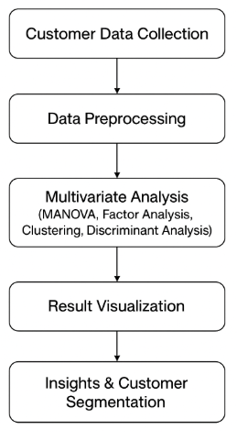

  - Data Flow Diagrams

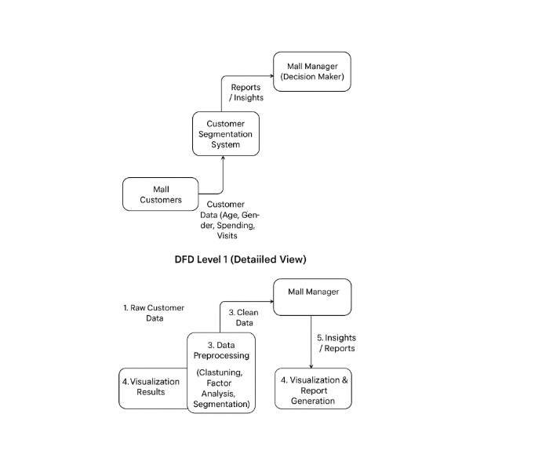

Data Flow Diagram Level 0

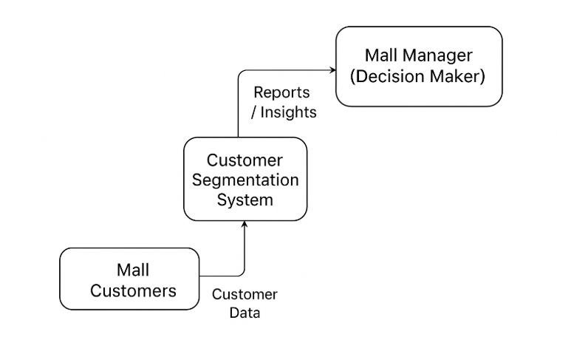

Data Flow Diagram Level 1

  - Entity Relationship Diagrams

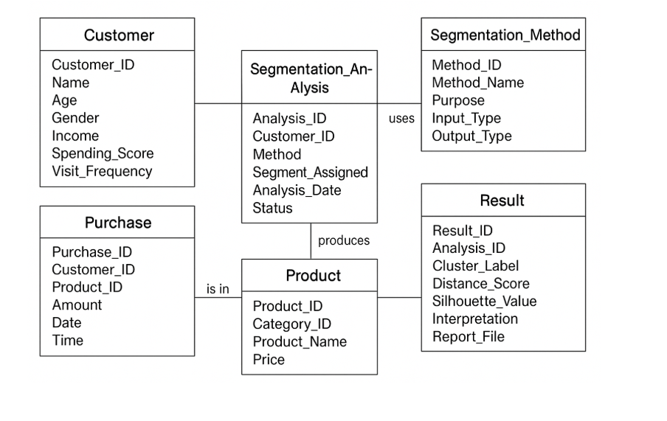

  - UML Diagrams

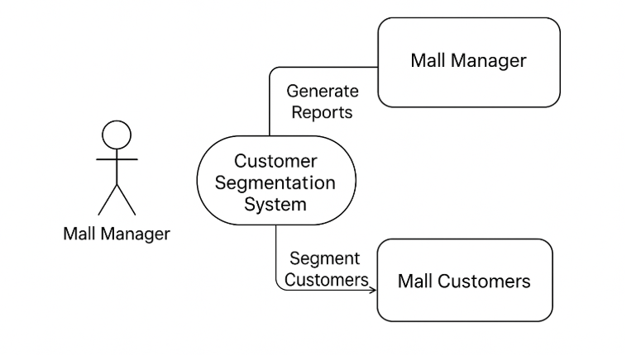

3.5 Data Dictionary
4 Software Testing

Types of Testing

- Unit Testing :
Unit testing focuses on checking the correctness of individual components of the system.
In this project, it includes testing:
- Data import and export functions
- Data cleaning and preprocessing modules
- Statistical functions such as clustering, factor analysis, correlation, and segmentation algorithms
Each module is tested separately to ensure accuracy, early error detection, and smooth functioning of customer data analysis.

- Integration Testing:
Integration testing verifies if all modules work correctly when combined.
For this project, it checks:
- Whether imported customer data flows properly into preprocessing
- Whether cleaned data is correctly passed to clustering or segmentation models
- Whether results are accurately sent to visualization and report modules
This ensures smooth workflow between data collection, analysis, and output generation without errors.

Testing Tools for project:

- IBM SPSS: For performing clustering, factor analysis, and generating validated results.
- R Software: Provides flexible multivariate analysis and automated validation scripts.
- Python: Using Pandas, NumPy, SciPy, Scikit-learn for data processing and model testing.
- Microsoft Excel: Used for initial data validation and simple visual checks.
- Version Control Tools (Optional): GitHub or Google Drive for maintaining datasets and tracking changes.

Test cases & Test Results

Test Case ID | Module Tested | Test Performed | Expected Result | Status
TC01 | Data Import | CSV dataset | Data should be load without errors | Pass
TC02 | Data Preprocessing | Raw survey responses | Missing values replaced or handled | Pass
TC03 | MANOVA Analysis | Multi-variable dataset | Correct factors corrected | Pass
TC05 | Result Visualization | Result Visualization | Charts showing correct group differences | Pass

GUI Testing

Test Case ID | Module Tested | Test Performed | Expected Result | Status
TC01 | Data Import | CSV dataset | Data should be load without errors | Pass
TC02 | Data Preprocessing | Raw survey responses | Missing values replaced or handled | Pass
TC03 | MANOVA Analysis | Multi-variable dataset | Correct factors corrected | Pass
TC05 | Result Visualization | Result Visualization | Charts showing correct group differences | Pass

Table: Login Test Case

Test Case | Test Scenario | Test Steps | Input Data | Expected Result | Actual Result | Status
CS01 | Valid Customer Segmentation | Enter complete demographic and purchase data run segmentation | Age: 25, Gender: F Spending Score: 80 | Customer assigned correctly | Segment assigned correctly | Pass
CS02 | Missing Demographic Data | Leave demographic fields blank and run segmentation | Age: -5 Gender: "" Income: 40k | System prompts for missing mandatory fields | Validation message displayed | Pass
CS03 | Invalid Age Input | Enter neggate ot vonong | Age: -5 or 'abc' Income: 40k | System assengses correctly | Segment assigned | Pass
CS04 | Boundary Values for Spending Score | Enter evernge lanre spending score | Spending Score: o or 100 | System accates t correctly | Segment assigned | Pass
CS05 | High Income Low Spending Case | Enter atterttiel vadues' spending score | Smty anoe pgr | System assigns to at low engagement | Segment correctly | Pass
CS06 | Low Income High Spending Case | Enter password in passwo | Cnsgeni anoer | System assigns to "Potential Risk / Hi... | Segment assigned | Pass
CS07 | Data Format Validation | Error 'iyouogrnoered enough formats | Income: tpt Score: ter | System assigns to Porrnential sameck... | Segment assigned | Pass
CS09 | Segmentation Result Display | Enter enttern or nag password | Error messag red tD'ner | Segment assigned correctly | Segment assigned | Pass

Results

Outcomes :

- Accurate segmentation of mall customers based on multiple variables such as demographics, spending patterns, and shopping behaviour.
- Identification of clear customer groups that reveal hidden patterns and relationships in shopper data.
- Reliable and meaningful results using multivariate techniques like cluster analysis and PCA.
- Clear visualization of customer segments through charts, tables, and graphs for easy interpretation.
- Enhanced decision-making for mall management in marketing, store planning, and customer service strategies.
- Improved understanding of how multivariate analysis strengthens customer segmentation and supports data-driven retail management.

5.1Screenshots

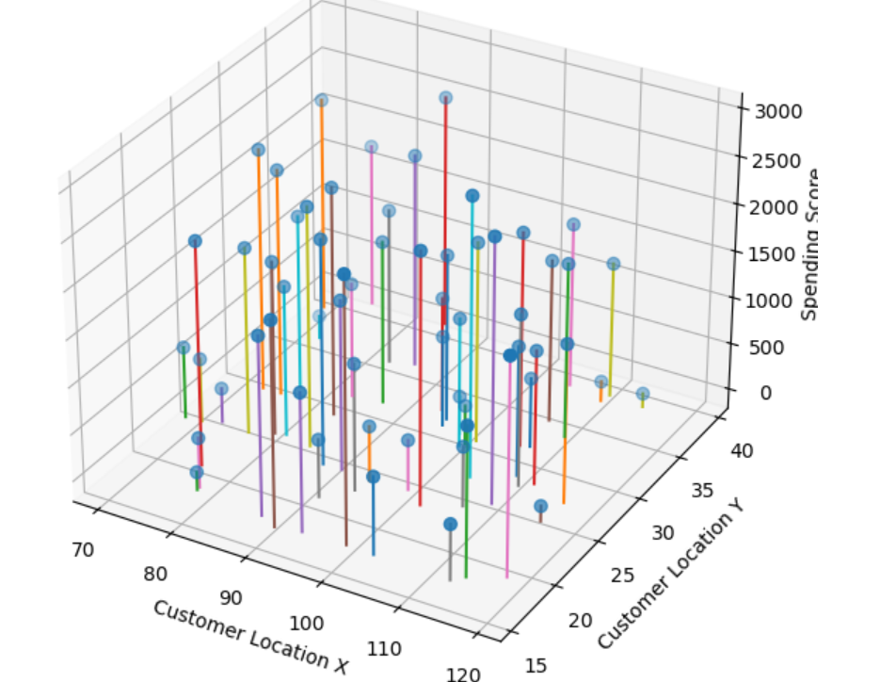

6.Conclusion

6.1Conclusion
Customer segmentation is a valuable approach for malls because it helps in understanding different types of shoppers and their unique behaviours. By using multivariate analysis techniques such as cluster analysis and PCA, malls can study many customer factors at the same time—like shopping patterns, spending habits, and preferences. This leads to clearer and more accurate customer groups. With these insights, mall management can make better decisions about marketing, store arrangements, and customer services. Overall, multivariate analysis makes customer segmentation more meaningful and helps malls improve customer satisfaction and overall performance.

6.2Future Scope

he future scope of customer segmentation in malls is broad and highly promising. With the growth of digital technologies, malls can integrate advanced data sources such as loyalty programs, mobile apps, footfall tracking, and online shopping behaviour to create even more detailed customer profiles. Machine learning and AI-based segmentation techniques can further help identify emerging trends and predict customer needs more accurately. Additionally, real-time data analysis can allow malls to personalize offers, improve store layouts, and enhance customer experience instantly. As customer expectations continue to evolve, future research can explore hybrid segmentation models that combine demographic, behavioural, and psychographic factors. Overall, expanding the use of technology and advanced analytics will make customer segmentation more precise, dynamic, and valuable for mall management

